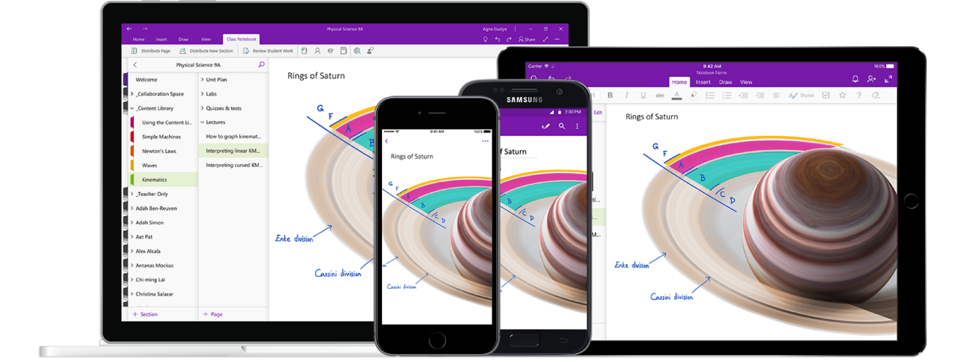

*Figure 1 cited from* [*Microsoft OneNote’s Official Website*](https://www.microsoft.com/zh-cn/microsoft-365/onenote/digital-note-taking-app?ms.url=onenotecom&rtc=1)

Analyzing the Design of Microsoft OneNote - version 16.0.13530.20440 or later

Software Analysis and Design Report | Jan 30th, 2021 | Hairong Wu (Jason) | 1706 words

# About the Product

Microsoft OneNote is one of the bundled software in Microsoft 365 series. It focuses on providing both students and workers in various fields with simple and powerful features to take notes. One can simply click on the small icon within the task bars and start recording their contents. Users can also create different notebooks for various purposes. By naming a notebook can they recognize what this notebook is used for. In addition, within a notebook, tabs can be created to filter huge sections of users’ projects or lectures. They can also add pages for detailed contents, pictures and drawing.

I choose to make a research on Microsoft OneNote because I’m always one of the stakeholders of it and, with no doubt, this software would keep influencing its stakeholders by providing new features which might have advantages or drawbacks. It is indeed that the latest version of OneNote (I believe starting at the version of 16.0.13530.20440 or later) has great updates on both its features and software layouts, which has costed effects not only on me but on other stakeholders and even several potential future users; for instance, users who prefers to create plenty of tabs would find it hard to switch between their tabs because all the tabs will be automatically combined.

Therefore, in this research paper, I will discuss on the current direct stakeholders, indirect stakeholders, design critiques and a redesign proposal for a possible prototype

# Stakeholder Research

## Direct Stakeholders

All students, especially those in high school and in college, and workers are direct stakeholders. After researching, students and workers who prefer to use a Windows system or Microsoft device such as Surface books are more likely to be direct stakeholders. There are two main reasons why they use OneNote instead of other kinds of notebook software.

Firstly, they are using Microsoft 365, so OneNote is pre-installed on their computer which they can use as a tool immediately after they get their new computer. These stakeholders also prefer to use OneDrive instead of other cloud syncing systems like iCloud. Therefore, using the entire series of Microsoft products can facilitate their working experience via software such as Microsoft Word, Microsoft PowerPoint, and Microsoft Outlook.

Secondly, OneNote could provide a better experience while using a touchscreen device like iPad and Surface book series. One can easily take notes through OneNote just like taking notes on a real notebook and have the same experience comparing writing on papers.

The two conclusions are derived through my interviews and surveys to these stakeholders. I send links to students in both US and Chinese high schools and colleges, and my internship colleagues. I also post the survey on social networks for receiving genuine responses.

For these stakeholders, they think OneNote provides them a better method to make their work easier. They can always find the features they want and utilize tools to achieve what they expect; for instance, if they want to create a polynomial graph and draw lines and dots on it, they could easily do so and make drawings on it, just like how they do this on their physical notebooks.

Unfortunately, the current OneNote version does make sense to those touchscreen users, however, for those who are using a computer and tablet, they are facing the same issue on the annoying design of tab switching, drawing function, and editing features such as resizing and color text. These features should be designed clear and simple for them. However, they are now confused by these functions and even do not know how to find these things and thus utilize them.

## Indirect Stakeholders

Indirect stakeholders are those who prefer to use other notebook systems and Apple users who are using iClouds. They are considered as indirect stakeholders because: 1) other notebook software sometimes does not make sense to them, probably having issues and bugs which does not represent its unique features, 2) Microsoft OneNote is now supporting syncing by iCloud and can be well-utilized on Apple devices. Therefore, these users are somehow potential and future users of OneNote. In addition, the current design for OneNote does fit to these indirect stakeholders’ taste, such as supporting cooperating with systems and software that are not Microsoft products, and would attract them to use it.

# Design Critique

## Problem 1: Section Tabs, Groups, and Pages

As affordance, the new tab locations are great. Each has a unique color and covers the whole page, where users and designers may learn that this works as signifiers and will work as an overall title for all pages. This new design also shows a terrific mapping that when users change the click to change tabs, the background color will also be changed due to the tab’s color.

it’s good to follow Miller’s law, which is to keep 7 (plus or minus 2) items once (Miller’s Law, 2021). However, when the tabs exceed the maximum length, they will be automatically combined. This causes problems when stakeholders try to switch between those tabs, they have to make an extra click to expand the combined tabs. This would be extremely annoying when one tries to switch between tabs and search for some notes.

Each page has the same color and can be messy if there are lots of pages or a page has a long title. Due to the *Law of Uniform Connectedness*, elements with visual connection are more likely to be perceived than those without any connection (Law of Uniform Connectedness, 2021). On the other side, the design for tabs archives the idea of the Law of Uniform Connectedness well. It utilizes various colors to filter tabs which makes sense to its stakeholders.

In addition, as the *Law of Similarity Defined*, humans prefer to put similar items together as a complete picture and group (Law of Similarity, 2021). In this case, there occurs a pool visibility, where all the pages would be exactly the same color, shape, spacing and size. This would be messy for its stakeholders to find a specific page they are looking for, thus decreasing the efficiency of their working process.

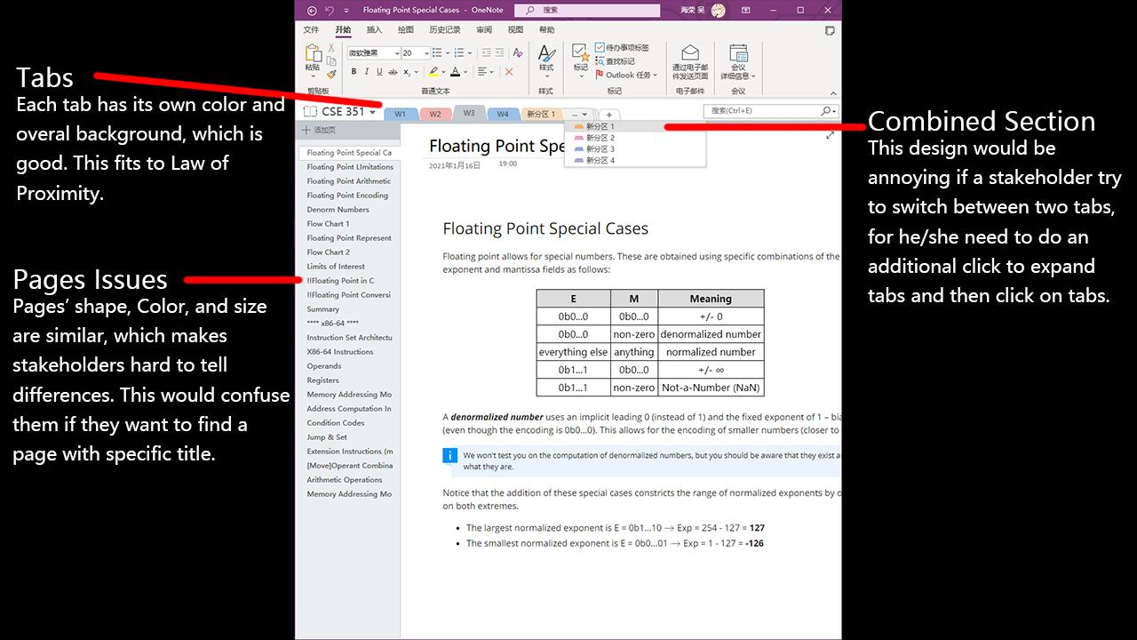

*Figure 2 Section Tabs, Groups and Pages problems*

## Problem 2: Pens in Drawing Section

The overall layout of the drawing section makes sense to stakeholders. In pens’ section, the shape and color of each pen as signifiers does clearly show the information that by choosing each block can they change the selected pen’s size and color. However, the feedback is weak. The selected items are only covered by a grey background, which is hard to observe what tool is currently chosen.

What’s more, for build-in pens, it does produce a good mapping and make sense to order pens by their colors and group by type of the pen. There is a mess on the last column where the colors on that column do not follow any of the two rules above. In addition, this pen arrangement would increase the num and complexity of choices for stakeholders, because it spends time to find the type of the pen with an expected color (Hick’s Law, 2021).

The color selection button follows the idea that the one that differs from the rest is most likely to be found, when multiple similar objects are presented (Von Restorff Effect, 2021). However, this costs a conflict with the *Law of Common Region* and produces a bad design. Therefore, this button becomes a poor-designed affordance. The conflicted aspect is that elements will be perceived into groups if they are sharing the same area with a clearly defined boundary (Law of Common Region, 2021). Here, although they are in a boundary, the boundary is not clear, for bold boundary of the box for selection pens makes a clear boundary, thus making the colour selection button seems to be considered as another feature that is not related to pen’s shape and colour. Stakeholders will lose themselves and cannot easily find where to change to other colours, just like the problems mentioned in the research.

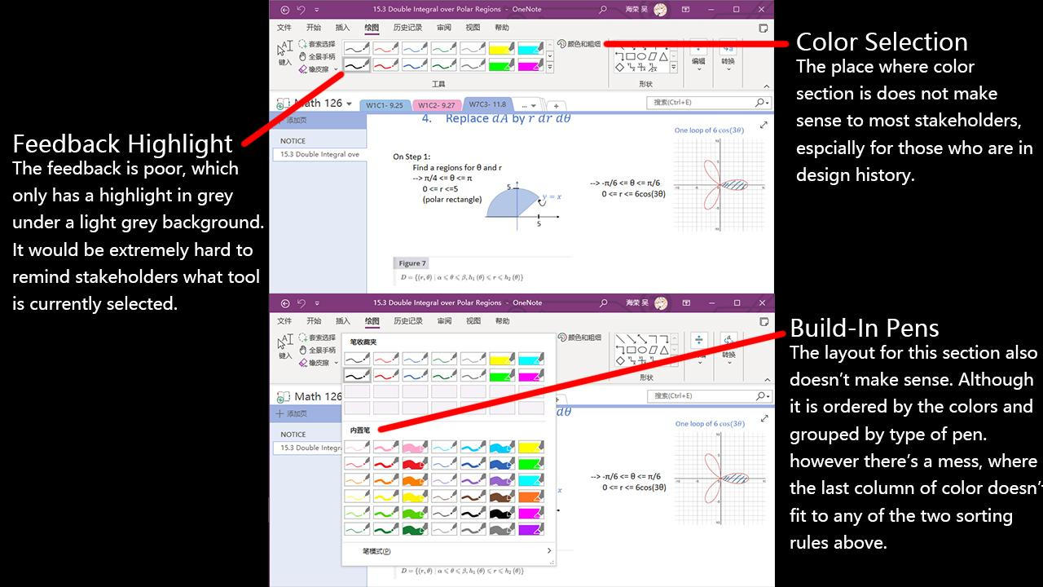

*Figure 3 Pens in Drawing Section*

# Redesign Proposal

As far as I’m concerned, I think of a way to resolve both the problem of the build-in pen section and the issue in the design of the color selection feature. I simply make some sketches, modifications and drawings on the original software’s screenshoot to represent the proposal.

## Idea - Redesign of Build-In pens and Color Selection

By making the pen’s shape selection and color section side by side can produce a good mapping to stakeholders, showcasing that this huge box is used to DIY your drawing pen. The left box and right box are individual signifiers, which implies two sections’ features.

The idea is generated while thinking of making the two information processes, which are selecting types and selecting color, as a combined group that could tell the users that they have relationships. In addition, the two sections should be individual, but strongly follow the rule that elements will be perceived into groups if they are sharing an area with a clearly defined boundary (Law of Common Region, 2021).

In addition, to keep the original idea of providing built-in pen style and colors, the new design simply inherits the idea to expand for more styles and colors, which also allows stakeholders to choose what they want and facilitate DIY ideas.

Another possible variant might be the design in the pen feature in Adobe Photoshop, where pen shape will only appear the currently selected one and can be changed by clicking and expanding to show more styles. This idea is a great UI design to simplify the entire software interface and does fit to those who have experiences in using such a product. However, it could be confusing for other students and workers to utilize and can delay their study and working process.

Therefore, by considering the research result from stakeholders and current design in OneNote and other kinds of software, I choose to implement the improved drawing interface as shown in *Figure 4* and *Figure 5*.

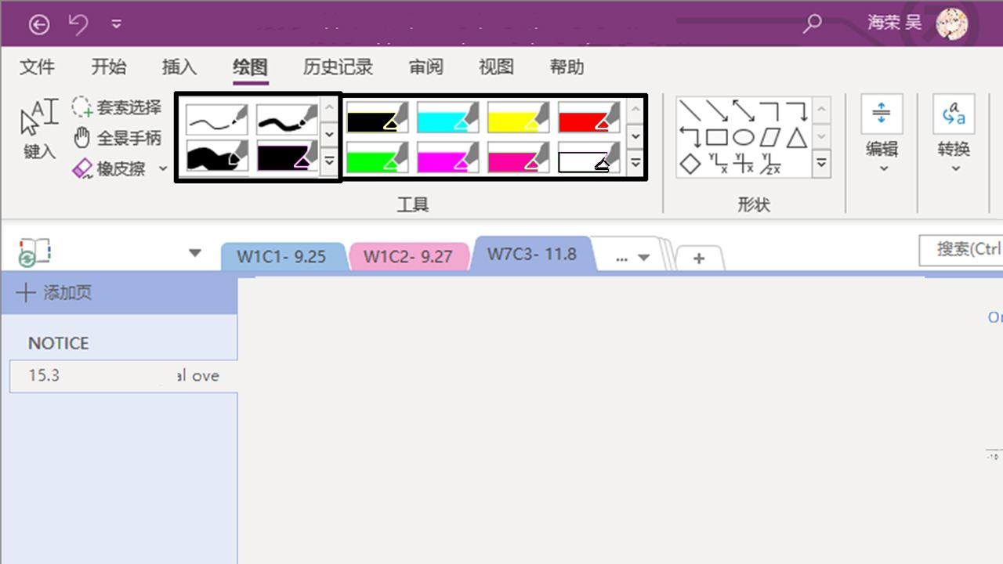

*Figure 4 A redesigned proposal demo*

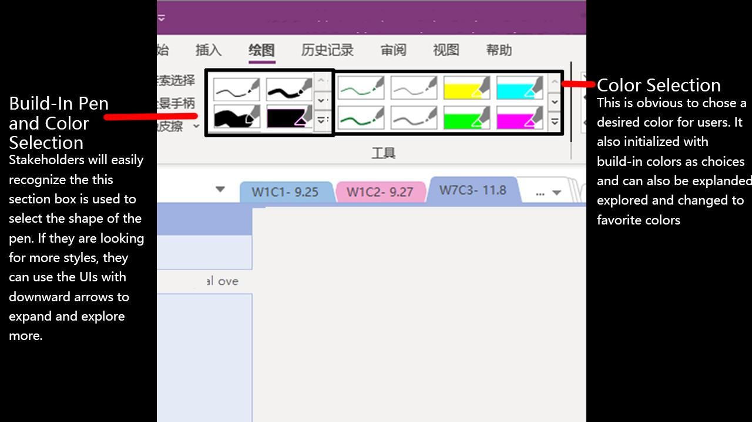

*Figure 5 A redesigned proposal demo’s description*

# References

*Hick’s Law*. (2021, 2 1). From Laws of UX: https://lawsofux.com/laws/hicks-law/

*Law of Common Region*. (2021, 2 1). From Laws of UX: https://lawsofux.com/laws/law-of-common-region/

*Law of Similarity*. (2021, 2 1). From Laws of UX: https://lawsofux.com/laws/law-of-similarity/

*Law of Uniform Connectedness*. (2021, 2 1). From Laws of UX: https://lawsofux.com/laws/law-of-uniform-connectedness/

*Miller’s Law*. (2021, 2 1). From Laws of UX: https://lawsofux.com/laws/millers-law/

*Von Restorff Effect*. (2021, 2 1). From Laws of UX: https://lawsofux.com/laws/von-restorff-effect/

# Appendix

Survey Result:

|  |  |  |  |  |  |  |  |
| --- | --- | --- | --- | --- | --- | --- | --- |
| Which one applies to you? | Which kinds of device do you prefer to use? | How do you prefer to use OneDrive as Cloud Drive? | Do you use Microsoft 365? (Word, PPT, Excel, etc.) | How often do you use Microsoft 365? | Do you use Microsoft OneNote? | How often do you use Microsoft OneNote? | Which other notebook software do you use? |
| Student under High-school | Tablet/iPad/Smart Phone | 1 | No | Rarely use it on my projects or lectures | No | Rarely use it on my projects or lectures | Apple Note |
| High-School Student | Tablet、Windows Computer/iPad/Smart Phone | 1 | No | Rarely use it on my projects or lectures | No | Rarely use it on my projects or lectures | Notability |
| Student under High-school | Tablet/iPad/Smart Phone/Microsoft Surface series | 3 | Yes | For all my projects or lectures | No | Rarely use it on my projects or lectures | Notability |
| Already worked in industry | Tablet/iPad/Smart Phone | 2 | No | Rarely use it on my projects or lectures | No | Rarely use it on my projects or lectures | Apple Note |
| College Student | Tablet、Windows Computer/iPad/Smart Phone | 5 | Yes | For all my projects or lectures | Yes | For all my projects or lectures |  |
| High-School Student | Tablet、Windows Computer/iPad/Smart Phone | 3 | No | Rarely use it on my projects or lectures | No | Rarely use it on my projects or lectures |  |
| College Student | Tablet、Windows Computer/iPad/Smart Phone | 4 | Yes | For all my projects or lectures | Yes | For all my projects or lectures |  |
| Already worked in industry | Tablet/iPad/Smart Phone | 5 | Yes | Some projects or lectures | Yes | Some projects or lectures |  |
| College Student | Tablet/iPad/Smart Phone | 5 | Yes | For all my projects or lectures | Yes | For all my projects or lectures | Apple Note |
| College Student | Tablet/iPad/Smart Phone | 2 | No | Rarely use it on my projects or lectures | No | Rarely use it on my projects or lectures |  |
| College Student | Tablet/iPad/Smart Phone | 3 | No | Rarely use it on my projects or lectures | No | Rarely use it on my projects or lectures |  |
| College Student | Tablet/iPad/Smart Phone/Mac Book | 4 | No | Rarely use it on my projects or lectures | Yes | Some projects or lectures |  |
| College Student | Tablet/iPad/Smart Phone/Mac Book | 2 | No | Rarely use it on my projects or lectures | No | Rarely use it on my projects or lectures |  |
| College Student | Tablet/iPad/Smart Phone/Microsoft Surface series | 3 | Yes | Some projects or lectures | Yes | Some projects or lectures |  |
| High-School Student | Tablet/iPad/Smart Phone | 3 | Yes | Some projects or lectures | Yes | Some projects or lectures |  |
| High-School Student | Tablet/iPad/Smart Phone | 2 | No | Rarely use it on my projects or lectures | No | Rarely use it on my projects or lectures | Apple Note |
| College Student | Tablet/iPad/Smart Phone | 2 | No | Rarely use it on my projects or lectures | No | Rarely use it on my projects or lectures |  |
| Already worked in industry | Tablet/iPad/Smart Phone | 3 | Yes | Some projects or lectures | Yes | Some projects or lectures | Notability |
| High-School Student | Tablet/iPad/Smart Phone/Microsoft Surface series | 4 | Yes | Some projects or lectures | Yes | Some projects or lectures |  |
| High-School Student | Tablet/iPad/Smart Phone/Microsoft Surface series | 5 | Yes | For all my projects or lectures | Yes | Some projects or lectures |  |
| College Student | Tablet/iPad/Smart Phone | 4 | Yes | For all my projects or lectures | Yes | For all my projects or lectures |  |
| College Student | Tablet/iPad/Smart Phone | 4 | Yes | For all my projects or lectures | Yes | Some projects or lectures |  |
| College Student | Tablet/iPad/Smart Phone/Mac Book | 3 | No | Rarely use it on my projects or lectures | No | Rarely use it on my projects or lectures | Apple Note |
| High-School Student | Tablet/iPad/Smart Phone/Mac Book | 2 | No | Rarely use it on my projects or lectures | No | Rarely use it on my projects or lectures | Notability |
| College Student | Tablet/iPad/Smart Phone | 1 | No | Rarely use it on my projects or lectures | No | Rarely use it on my projects or lectures | Apple Note |
| Already worked in industry | Tablet/iPad/Smart Phone/Mac Book | 1 | No | Rarely use it on my projects or lectures | Yes | Some projects or lectures | Apple Note |

* Interview Transcripts
* Survey Results
* Additional screenshots
* More design ideas and wireframes
* More information about the product

There is no minimum length for the paper, just be sure you addressed all the questions. Max length is ~1750 words **excluding references and the appendix**. If you reference external sources, be sure to cite those sources properly. You may want to re-read the plagiarism section of the course syllabus page.